Endless Arguments

Pirkei Avos 5:20
Any dispute that is for the sake of Heaven will have a constructive outcome; but one that is not for the sake of Heaven will not have a constructive outcome...

#1
SAFE SPACE (definition)
A space in which you are protected against hearing views which might cause you distress. For example, “trigger warnings,” “microaggressions,” or any remark that someone might find offensive even if no offence is meant.

Jean M. Twenge, iGen, Atria, 2017, 253
Increasingly, speakers with controversial views are being disinvited: the number of such incidents on American college campuses rose from 6 in 2000 to 44 in 2016.

Question: What do you think about “safe spaces” on college campuses?

#2
Question: Is the exchanging of views and differences positive or negative for building and maintaining healthy relationships?

#3
Question: What makes a disagreement turn into a fight?

#4
Question: How does one disagree agreeably?

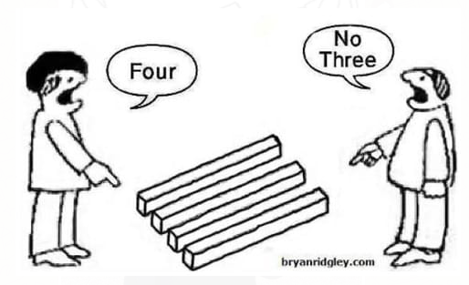

#5
Summary of the Torah Portion “Korach”
This took place during the 40 years the Jews were walking in the desert, on their way from Egypt to Israel after getting the Torah.
Korach got upset that Moshe had appointed his own brother Aaron as high priest (a highly privileged position), a position Korach wanted for himself. He began a rebellion against Moshe and Aaron, challenging their leadership and saying that G-d never chose them. All Jews are holy and created equal.
Korach persuaded over 250 distinguished members of the community to join him in trying to overturn the current power and to assume it for themselves.
Through the miraculous direct intervention of G-d, the rebellion stopped and the rebels were punished.

Pirkei Avos 5:20
...What sort of dispute was for the sake of Heaven? The dispute between Hillel and Shammai.
And which was not for the sake of Heaven? The dispute of Korach and his entire company.

Talmud, Yevamos 14b
The children of Hillel and Shammai intentionally married each other to show they were at peace.

Torah, Bamidbar 17:5
Don't be like Korach!
Talmud, Sanhedrin 110a
This is the prohibition against quarreling.

In order to use appropriate, parallel language in the Mishnah, the example should be "the dispute of Korach and Moshe" (the two adversaries), not "of Korach and his entire company." Moshe is not mentioned here at all.

Question: What could be the reason for this? What does it teach us?

#6
Britain's Former Chief Rabbi Lord Jonathan Sacks
The sages are here drawing a fundamental distinction between two kinds of conflict: argument for the sake of truth and argument for the sake of victory.

Question: How do you distinguish if you are arguing for the sake of truth or for the sake of victory?

#7
Questions:
(a) What DO you do when you realize that you are wrong in the middle of an argument?

(b) What SHOULD you do when you realize that you are wrong in the middle of an argument?

(c) How should you accept success or defeat in an argument?

#8
Question: What's your takeaway from today's discussion?

